**Day 5:**

**LeetCode: Bull and Cow**

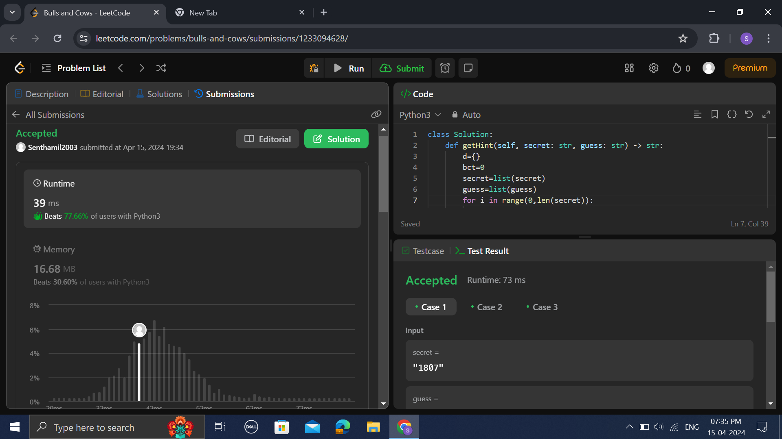

**2.Crud App for Employee:**

1.1Add Employee

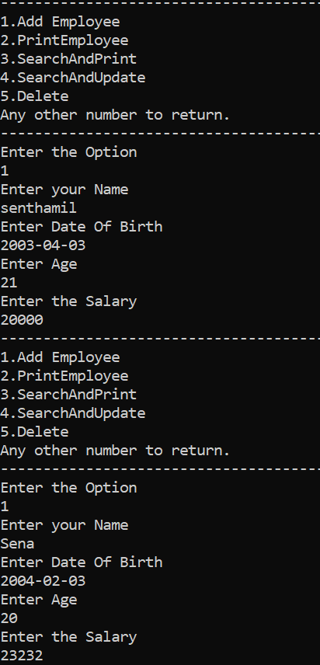

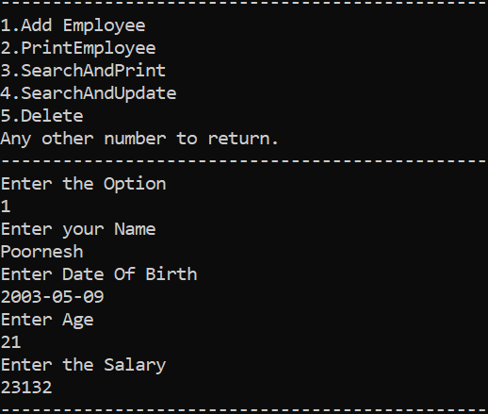

**2.PrintAll**

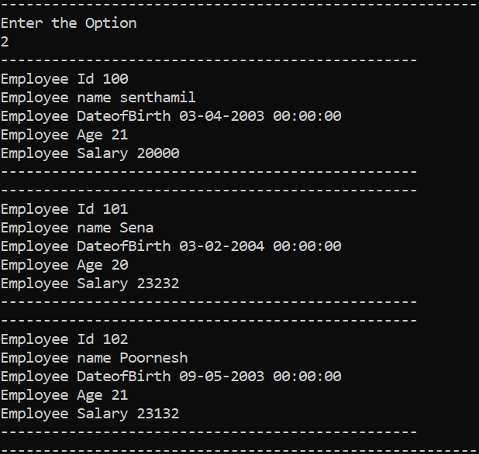

**3.Search By Id and Print**

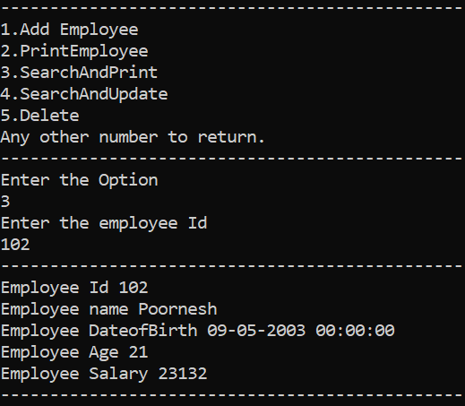

**4.SearchBy Id And Update:**

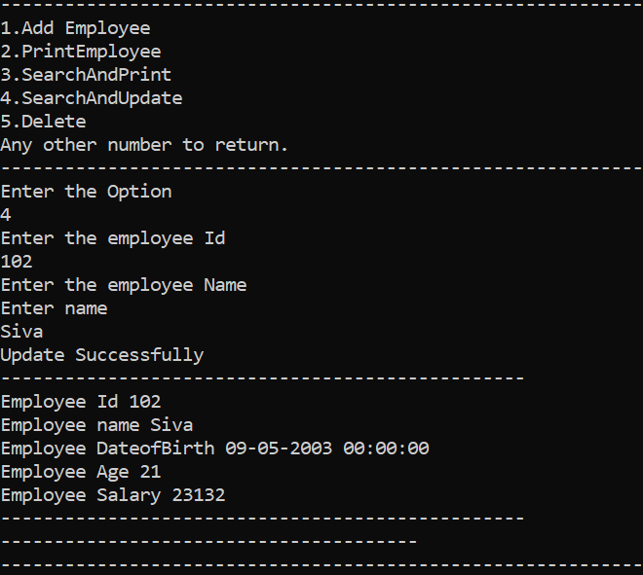

**5.SearchByIdAndDelete:**

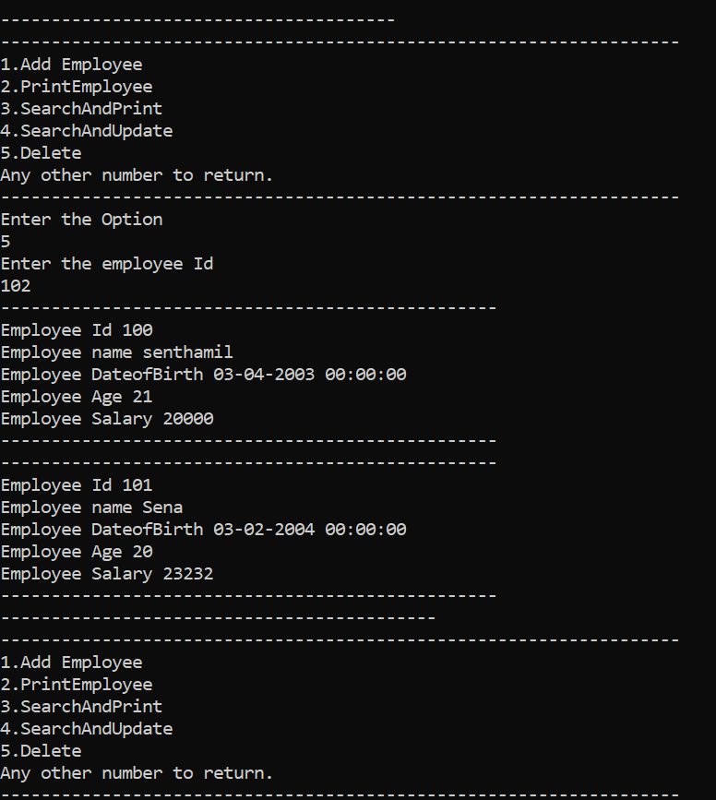

**2.CowAndBull In C#**

